Lab 18: Path traversal vulnerabilities
Objective:
- This lab is focused on exploring Path Traversal vulnerabilities, a type of security flaw where an attacker can access and potentially manipulate files on a server that are not intended to be accessible through the web application. Participants will interact with a simulated environment featuring a web application with path traversal vulnerabilities. The objective is to understand how these vulnerabilities are exploited, their potential impact on system security, and the strategies for mitigating them.
In this lab, students need to:
- Answer the following questions:
  - What is a Path Traversal vulnerability, and how does it differ from other types of web application vulnerabilities? Explain the concept of path traversal, including how attackers can manipulate input to access or manipulate files outside of the intended directory.
  - Describe the process for exploiting a Path Traversal vulnerability in a web application. What are the common methods or techniques used by attackers to manipulate file paths, and how can these methods compromise the security of a server?
- Perform challenge:
  - File path traversal, traversal sequences blocked with absolute path bypass
- Explain and capture all steps (full windows screen capture).
Group Members:
- Phạm Hoàng Hải Nguyên (SE180511)
- Nguyễn Trúc Quỳnh (SE180280)
- Giã Thị Nhã Trân (SE180405)

Submit a report addressing all the questions mentioned above in either PDF or Markdown format. Additionally, include a video demonstrating the detailed process of your work to ensure the authenticity of your lab exercise.
The report file name must be Class_YourStudentID _YourName_Lab18

File path traversal, traversal sequences blocked with absolute path bypass
Opens the "File path traversal, traversal sequences blocked with absolute path bypass" lab from PortSwigger Web Security Academy in Firefox inside a Kali Linux VM. Burp Suite Professional is already running with the Proxy intercepting traffic. The lab page explains that the application blocks standard traversal sequences like "../" but fails to validate absolute paths, and the goal is to retrieve the contents of the /etc/passwd file. The lab status shows "Not solved".
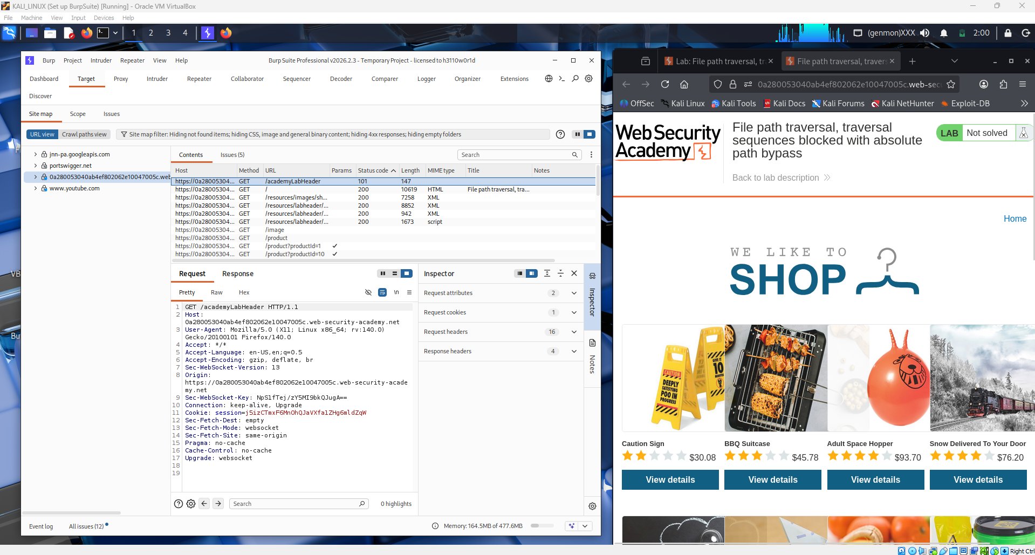

Browses the target shopping website and clicks on a product listing to load a product detail page. Loading this page causes the browser to make a GET request that fetches the product image, and this image request contains a filename parameter that is passed directly to the server's file system. Burp Suite captures all of these requests in the HTTP history tab as the student navigates through the shop.
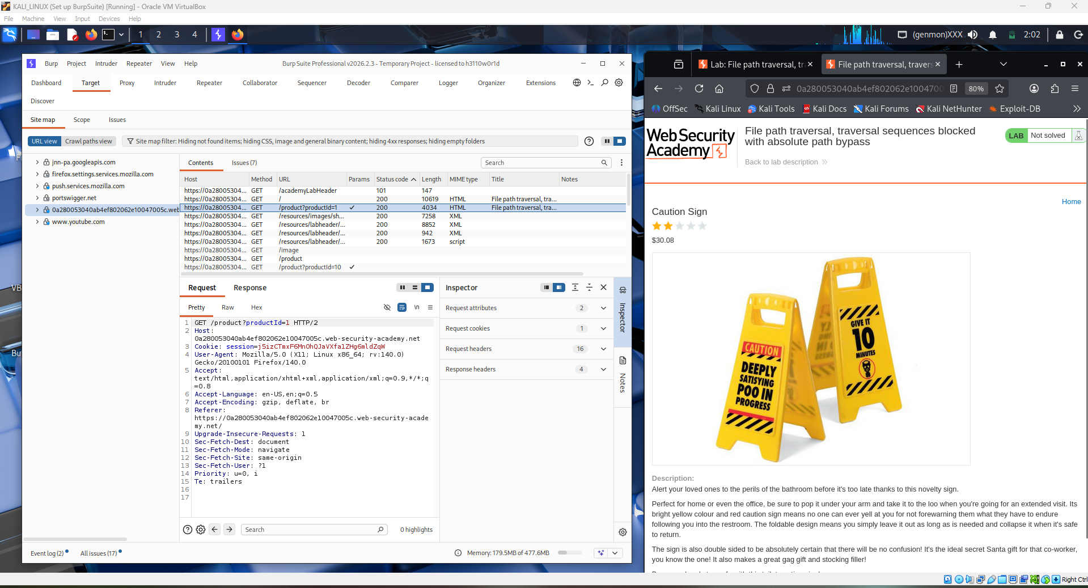Opens Burp Suite's HTTP history and locates the GET request to /image?filename=... which is the vulnerable endpoint responsible for serving product images. The filename parameter in the query string is the injection point. The student right-clicks this request and sends it to Burp Repeater so the filename value can be manually modified and re-sent without going through the browser.
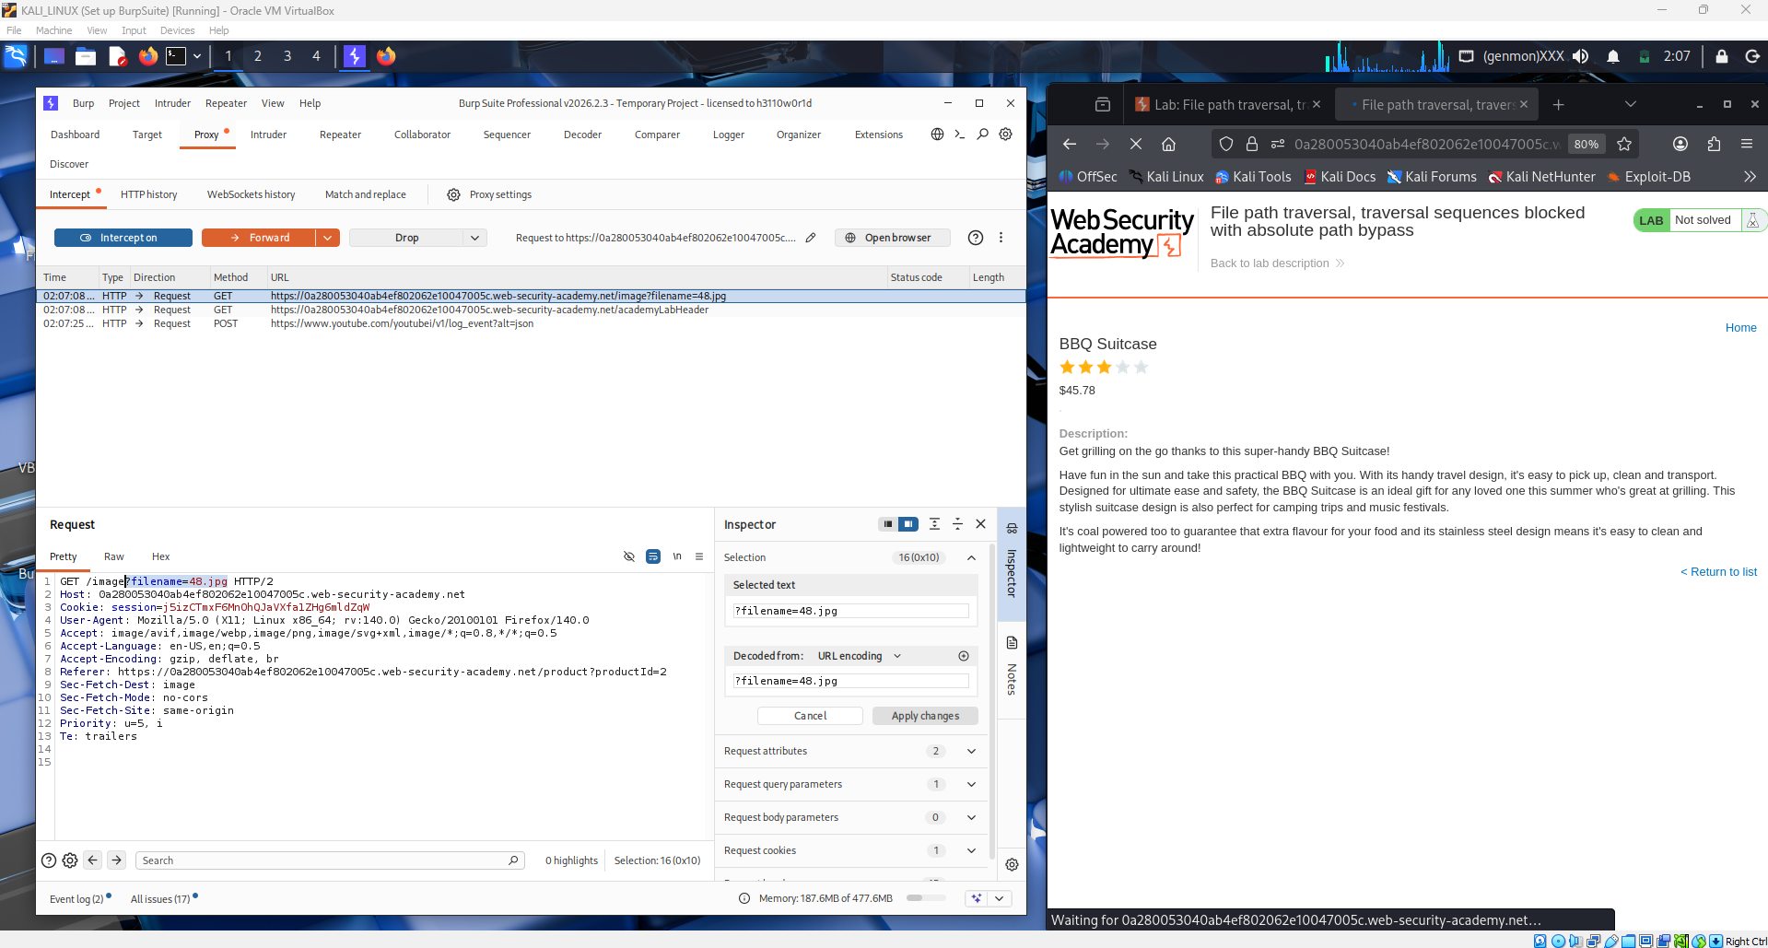
Inside Burp Repeater, the student modifies the filename parameter from its original value to /etc/passwd, using an absolute path instead of a relative traversal sequence. Because the application blocks ../ patterns but does not validate whether the supplied path is an absolute path starting from the root of the file system, /etc/passwd is accepted and passed directly to the underlying file read operation on the server.
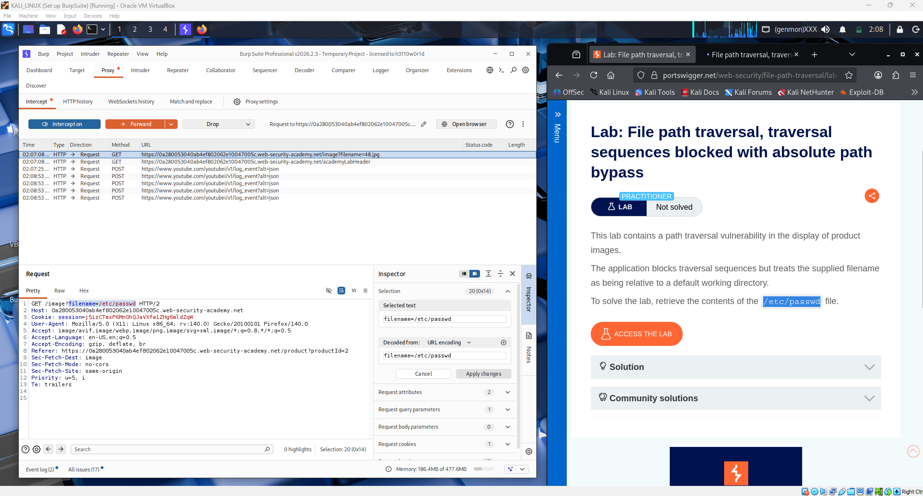
Clicks the Send button in Burp Repeater to submit the modified request. The server processes the request and, because the absolute path bypass is successful, returns the raw contents of /etc/passwd in the HTTP response body. The response panel displays the full contents of /etc/passwd, showing all system user accounts including root, daemon, and other system entries in the standard Unix passwd format.
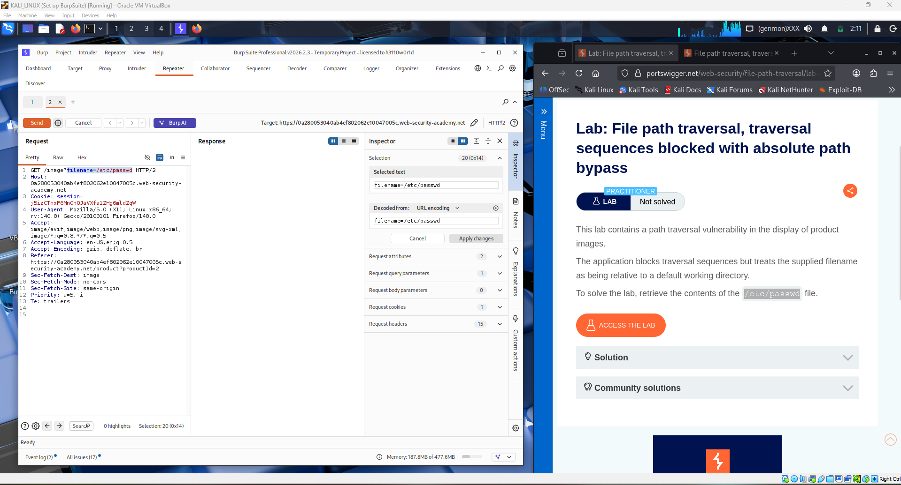
Switches back to the browser to confirm the result visually. The browser displays the raw text content of /etc/passwd rendered directly in the page where the product image was supposed to appear, confirming that the server returned the sensitive file content in place of the expected image. The full list of system users is visible in the browser window, demonstrating successful exfiltration of a sensitive server-side file.
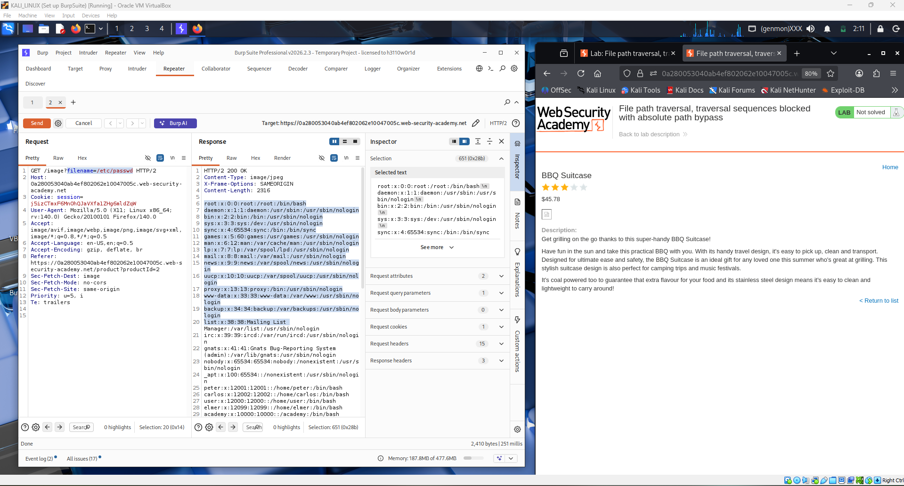
The lab banner updates to show "Solved" with a green confirmation message at the top of the browser. This confirms that the absolute path bypass technique successfully circumvented the application's traversal sequence filter, and the student has completed the lab by reading the contents of /etc/passwd from the server's file system through the vulnerable image filename parameter.
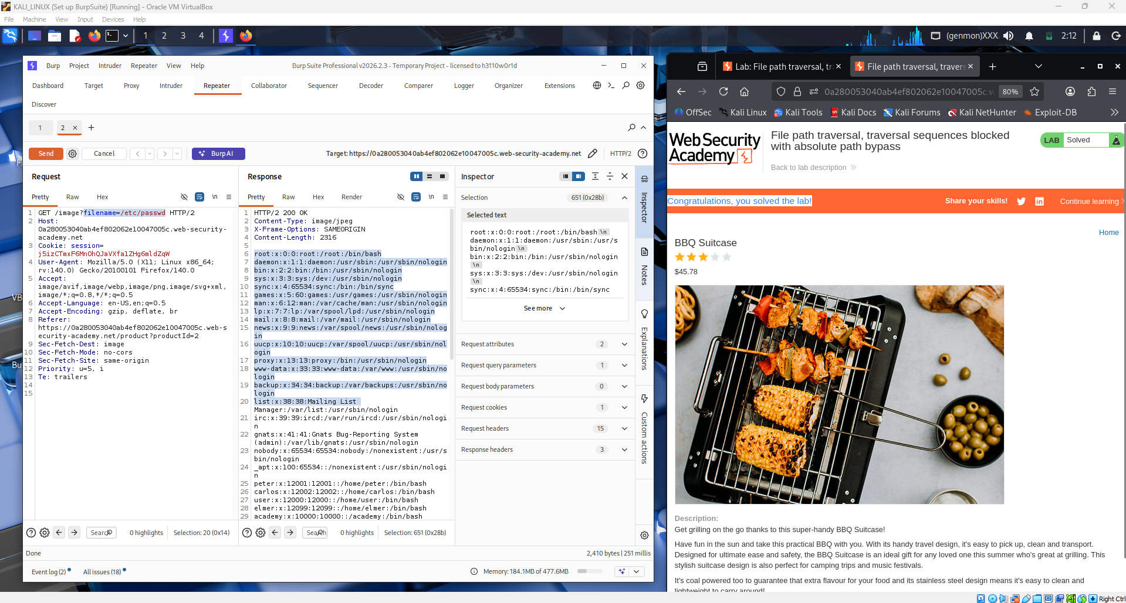
Question 1: What is a Path Traversal vulnerability, and how does it differ from other types of web application vulnerabilities?
A Path Traversal vulnerability, also known as directory traversal, occurs when a web application uses user-supplied input to construct a file path on the server without sufficiently validating or sanitizing that input. An attacker can manipulate the input to include special path navigation sequences such as ../ (dot-dot-slash) to move up the directory tree beyond the intended base directory, or by supplying an absolute path directly, thereby gaining access to files that were never meant to be reachable through the application. The classic attack payload is a sequence of ../ characters sufficient to climb to the root of the file system, followed by the target file path, for example ../../../../etc/passwd on a Linux server.
Path traversal differs from other web vulnerabilities in several key ways. Unlike SQL injection, which targets the database layer, or XSS, which targets the client-side browser, path traversal operates entirely at the file system level — its goal is to read, and in some cases write, arbitrary files on the server. Unlike SSRF, which causes the server to make outbound network requests, path traversal causes the server to read from its own local storage. Unlike authentication bypass or privilege escalation attacks, path traversal does not require any account or session and abuses the file-serving functionality directly. It is also distinct from command injection because the attacker is navigating the file system rather than executing arbitrary OS commands, though both can lead to full server compromise if chained. The damage from path traversal is primarily information disclosure — an attacker can read configuration files, private keys, application source code, credentials, and sensitive system files, all without triggering any authentication mechanism.

Question 2: Describe the process for exploiting a Path Traversal vulnerability in a web application.
Step 1 — Identify file-serving parameters. The attacker maps the application looking for any parameter whose value looks like a filename, path, or file reference. Common indicators include parameters named filename, file, path, page, template, doc, or img, and URLs that contain file extensions like .jpg, .pdf, or .html as parameter values.
Step 2 — Test basic traversal sequences. The attacker substitutes the filename parameter with a traversal payload such as ../../../etc/passwd and observes whether the server returns the file contents or an error. If the basic payload fails, the attacker tries bypass techniques including URL-encoded sequences (%2e%2e%2f), double-encoded sequences (%252e%252e%252f), and mixed-case or null-byte injections.
Step 3 — Apply the absolute path bypass. If the application strips or blocks ../ sequences but does not validate that the supplied value is a relative filename, the attacker can supply an absolute path directly, for example /etc/passwd on Linux or C:\Windows\win.ini on Windows. The application concatenates the base directory with the user input, but because the OS treats an absolute path as a complete path, the base directory is effectively ignored and the target file is read directly.
Step 4 — Enumerate sensitive files. Once traversal is confirmed, the attacker targets high-value files such as /etc/passwd and /etc/shadow for user credentials, application configuration files containing database passwords or API keys, private SSH keys at /home/user/.ssh/id_rsa, web server configuration files, and application source code files that might reveal further vulnerabilities.
Step 5 — Escalate impact. If the application also allows file writes through the same parameter, the attacker can plant webshells or overwrite critical configuration files. Even read-only access to private keys or credentials can be chained into full remote code execution by using the obtained secrets to authenticate directly to the server via SSH or the application's admin interface.

Conclusion
This lab demonstrated a path traversal vulnerability where the application's defense was incomplete. While the server correctly blocked the classic ../ traversal sequence, it failed to validate whether the supplied filename was an absolute path, allowing the attacker to bypass the protection entirely by simply providing /etc/passwd as the filename value. Using Burp Suite Repeater to modify the GET /image?filename= request, the student read the full contents of the server's /etc/passwd file in a single request with no authentication required. This highlights a critical lesson in security engineering: a blocklist that filters only one form of attack is never sufficient. Robust path traversal prevention requires canonicalizing the supplied path, verifying that it resolves to a location inside the permitted base directory, and ideally never constructing file paths from user input at all. Without this validation, any user with access to the image endpoint can read arbitrary files from the server's file system, potentially exposing private keys, passwords, and application secrets that can lead to full server compromise.

